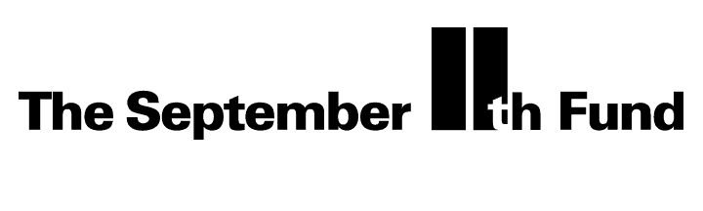

BOARD TALKING POINTS
Contact: Jeanine Moss 212 686-7097

The September 11th Fund
The September 11th Fund was established by United Way of New York City and New York Community Trust to meet the needs of victims, their families, and communities affected by the tragic events of September 11.

- Victims and families’ emergency needs are being met – and have been from the first weeks.

- The September 11th Fund supports organizations on the front lines who get help to those who need it.

- Our goal is to meet both immediate and longer-term needs fairly, quickly and efficiently.

- More than 1 million people donated to the Fund because The New York Community Trust and United Way of New York City have decades of experience funding organizations that help people.

- Administration costs have been raised separately so that 100% of the donations go to grants that help victims, their families and affected communities.

